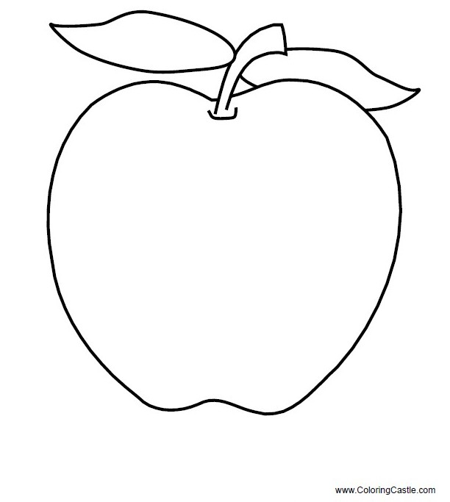

|  |  |  |  |  |  |
| --- | --- | --- | --- | --- | --- |
| J | A | B | L | K | O |
|  |  |  |  |  |  |

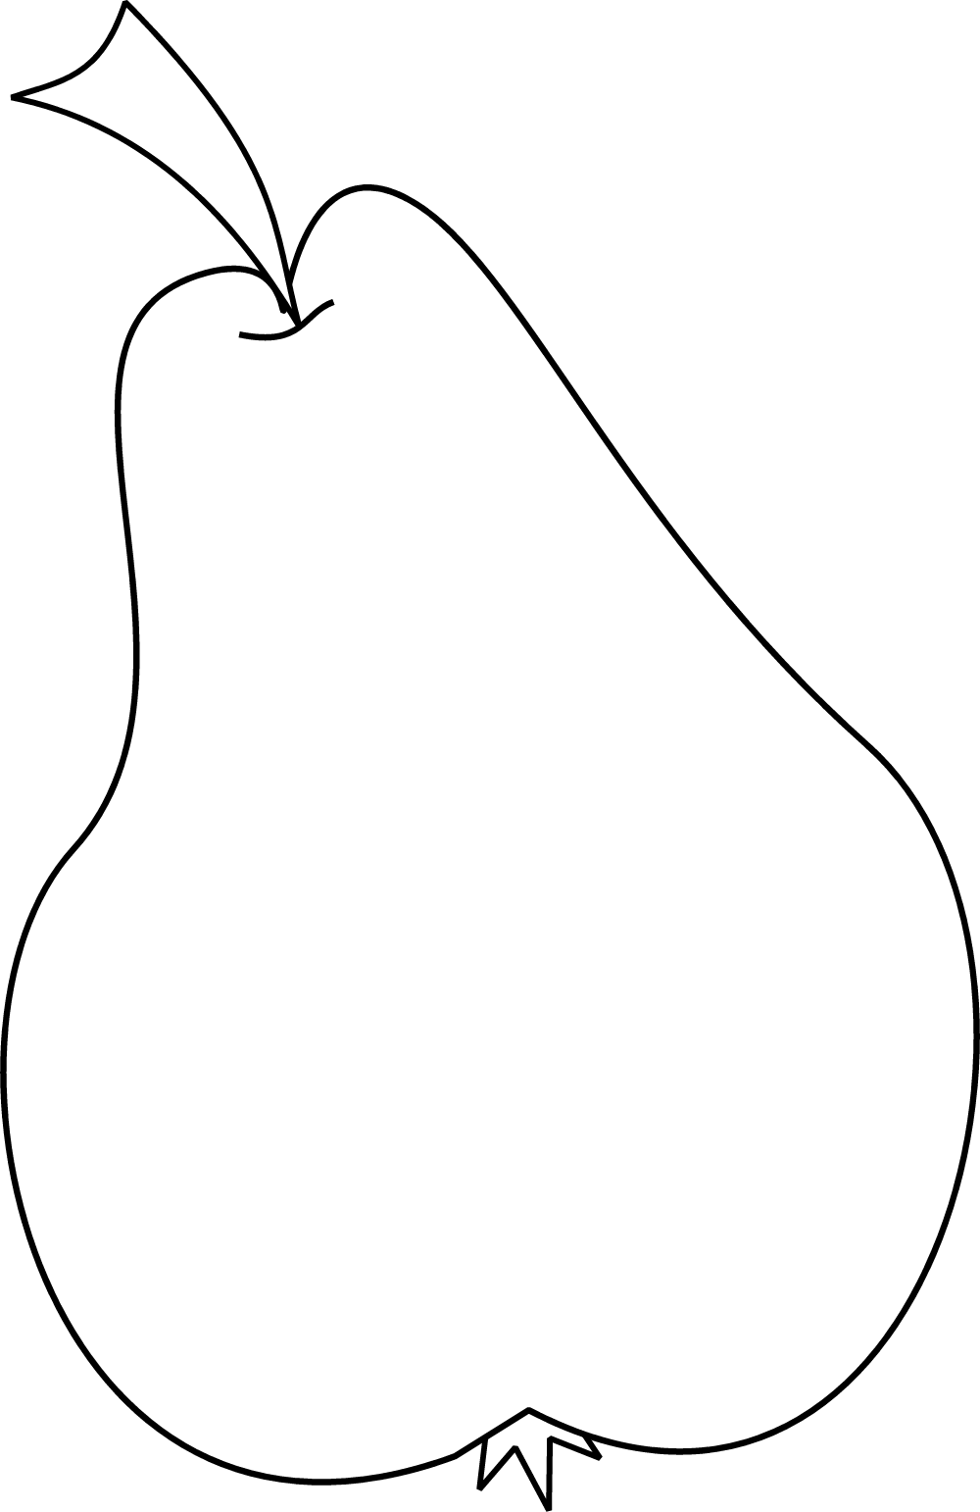

|  |  |  |  |  |  |
| --- | --- | --- | --- | --- | --- |
| H | R | U | Š | K | A |
|  |  |  |  |  |  |

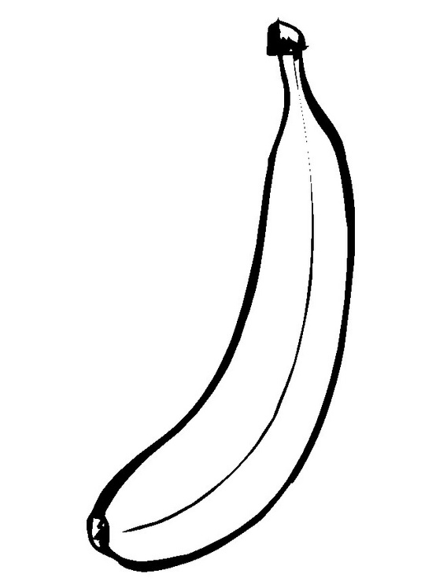

|  |  |  |  |  |
| --- | --- | --- | --- | --- |
| B | A | N | Á | N |
|  |  |  |  |  |

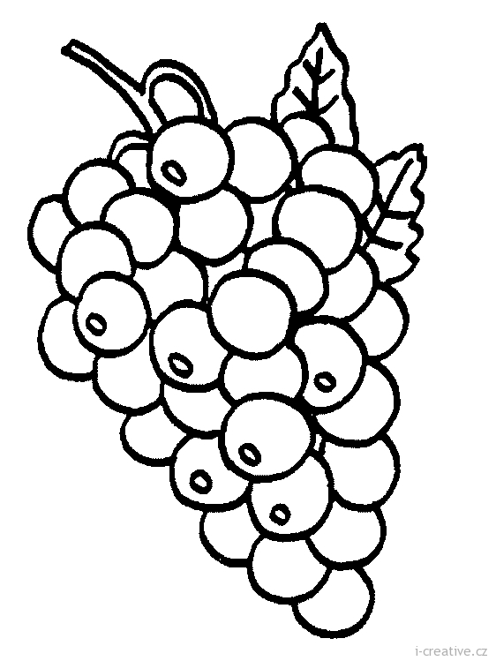

|  |  |  |  |  |  |
| --- | --- | --- | --- | --- | --- |
| H | R | O | Z | N | O |
|  |  |  |  |  |  |

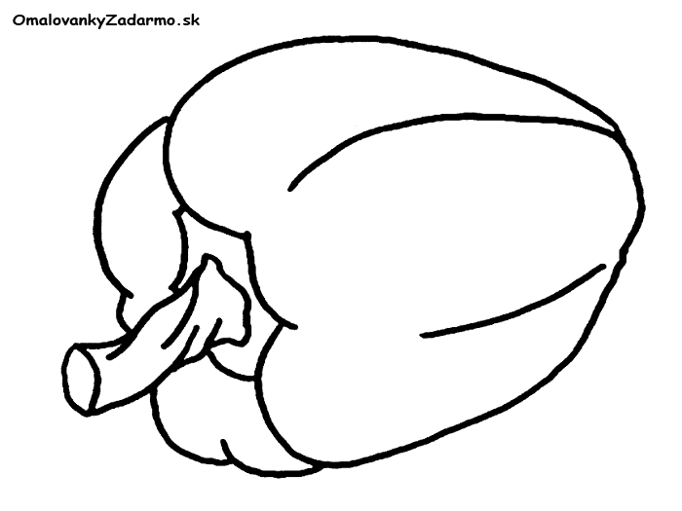

|  |  |  |  |  |  |  |
| --- | --- | --- | --- | --- | --- | --- |
| P | A | P | R | I | K | A |
|  |  |  |  |  |  |  |

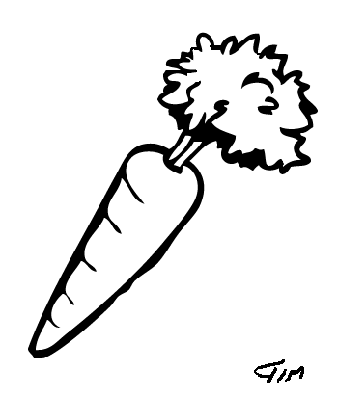

|  |  |  |  |  |
| --- | --- | --- | --- | --- |
| M | R | K | V | A |
|  |  |  |  |  |

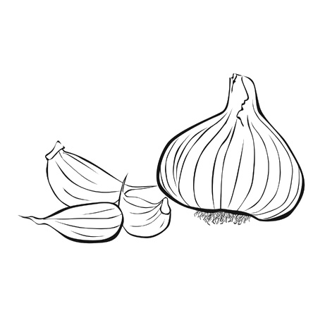

|  |  |  |  |  |  |
| --- | --- | --- | --- | --- | --- |
| C | E | S | N | A | K |
|  |  |  |  |  |  |

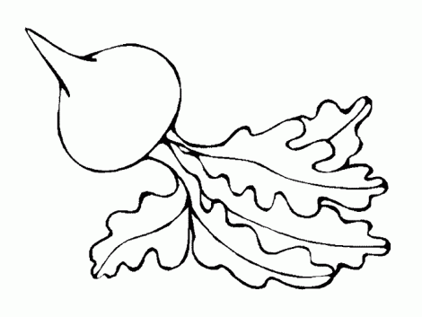

|  |  |  |  |  |  |  |  |
| --- | --- | --- | --- | --- | --- | --- | --- |
| R | E | Ď | K | O | V | K | A |
|  |  |  |  |  |  |  |  |